Student Worksheet: Is AI the new research buddy?
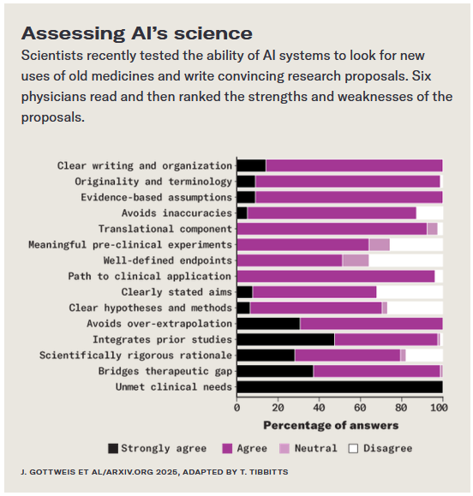
Directions: Powerful forms of artificial intelligence are now playing roles in research labs around the world. While they change how humans make discoveries, the AI tools aren’t fully autonomous yet. Some scientists are skeptical, while others are working to make the idea a reality. This could change how science is done.
Graph Questions
1. Of the topics listed in the graph, which of the following did almost all scientists agree was accomplished by AI during the writing of the research proposals? Choose all that apply.
- clear writing and organization
- avoids over-extrapolation
- scientifically rigorous rationale
- well-defined endpoints

2. What ability of the AI system did almost all the scientists agree on?

3. Of the following, which writing component did most scientists find that AI performed poorly?
- clear writing and organization
- avoids over-extrapolation
- scientifically rigorous rationale
- well-defined endpoints

4. Identify one of the writing components that none of the scientists strongly agreed that AI accomplished when writing the research proposals.

