Student Worksheet: What shape do you see in the sky?
Directions: Clouds take all sorts of shapes, from wispy to puffy to towering. Meteorologists, or weather forecasters, spend a lot of time predicting clouds and studying how they form because clouds are behind all storm systems — from tornadoes and hurricanes to rain and snowstorms. Using the graph from the article below, please answer the following questions.
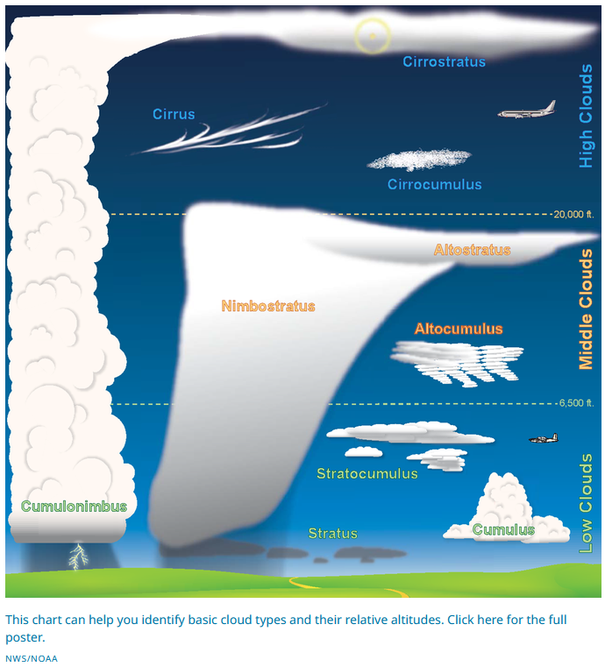
Graph Questions
1. At what altitude do you find cirrus clouds?
- between ground and 6,500 ft
- between 6,500 ft and 20,000 ft
- above 20,000 ft

2. Which of the following choices has the clouds listed in order from closest to the ground to the farthest?
- Nimbostratus, Stratus, Cirrostratus
- Altostratus, Stratus, Cirrostratus
- Altocumulus, Altostratus, Cumulus
- Stratus, Nimbostratus, Cirrostratus

3. According to the graphic, which type of cloud is most associated with thunderstorms?

4. Which type of clouds can stretch from the surface of the Earth to well over 20,000 ft?

