Student Worksheet: Positive connections limit bullying harm
Directions: Research suggests that stronger connections at school can help limit some of the harm from bullying, including mental health impacts. Building connectedness at school could help the millions of kids who have been bullied worldwide. Using the graph from the article below, please answer the following questions.
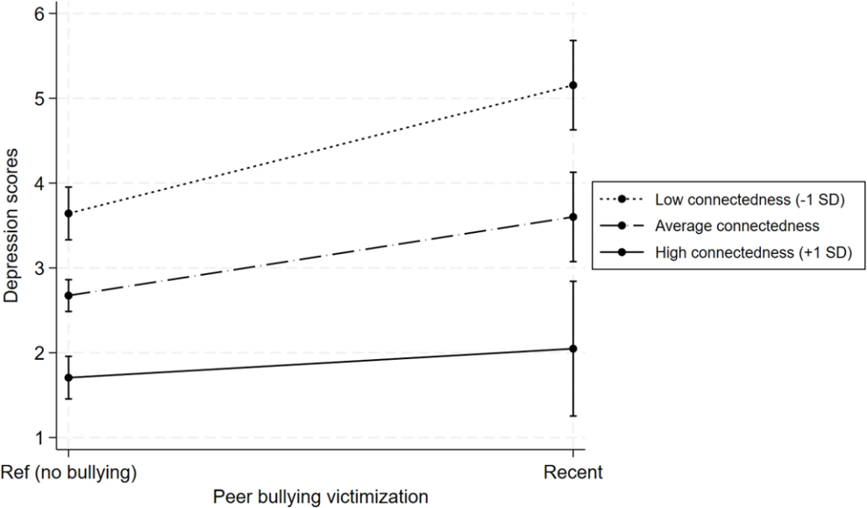
T. Ajibewa et al., BMC Public Health 2025 (CC BY-NC-ND 4.0)
Graph Questions
1. TRUE/FALSE: Students who feel connected to others at their school have a higher risk of depression.

2. FILL-IN-THE-BLANK: Students who faced recent bullying but feel connected at school show an average depression score of __.
- 1
- 2
- 3
- 4
- 5
- 6

3. What is the average depression score difference between a student who has been recently bullied but feels highly connected at school versus a student who has been recently bullied who does not feel connected at school?
- approximately 1 point lower
- approximately 2 points lower
- approximately 3 points lower

4. Recently bullied students that report having an average connectedness at school show a depression score of approximately 3.5. Which statement below is NOT true in comparison?
- Recently bullied students who report having low connectedness at school show a depression score over 5.
- Students who report having low connectedness at school show a depression score 3 points higher than students who report having average connectedness.
- Students who report having high connectedness at school show a depression score less than 2.5.

5. In your opinion, why do you think bullied students who feel connected at school have a better chance of fighting depression?

